RazorpayPaymentGateway

Paymentflow

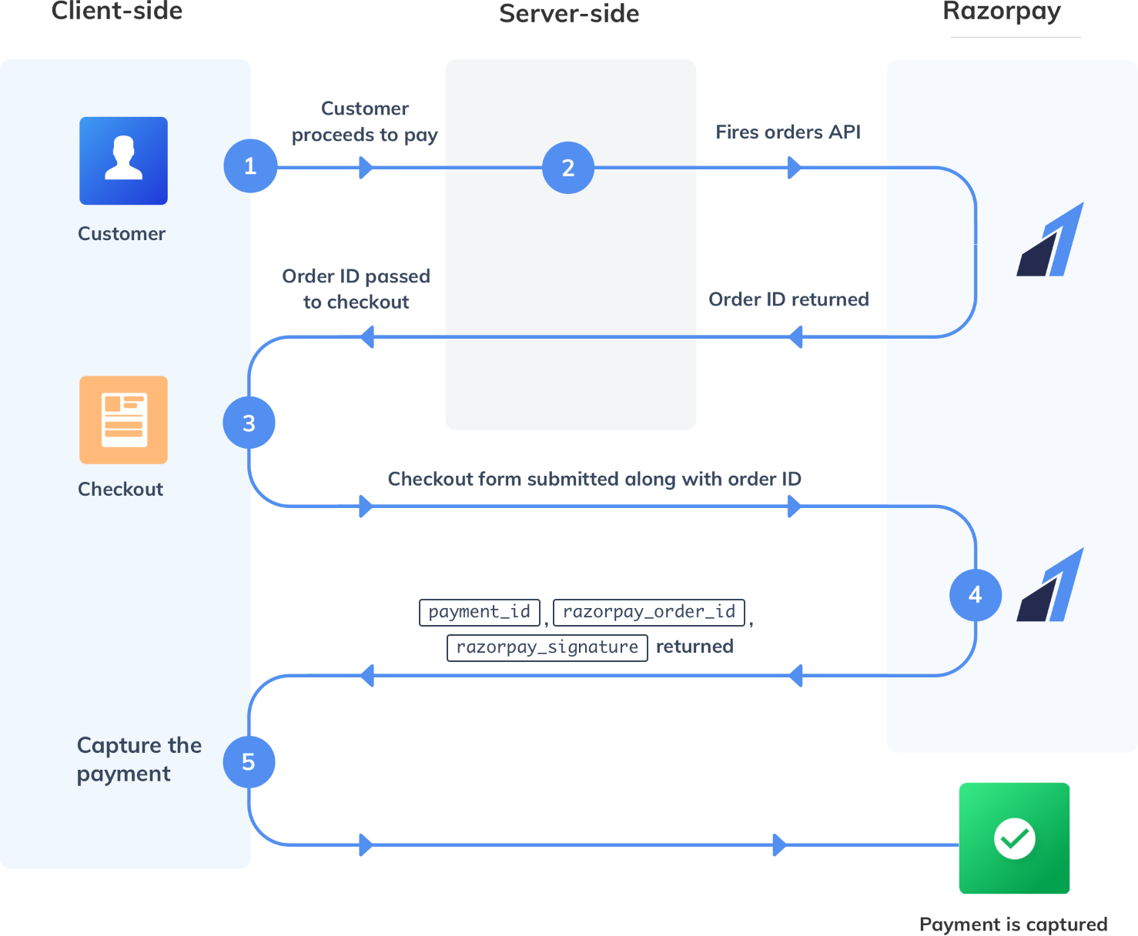

* CreateaRazorpayAccount
* GenerateanddownloadAPIKeys
* Createapaymentform.
* Whenuserclickonpaybuttonthensendtherequestto**server**andcreate

**order**atserversideusingrazorpayapiatbacked,ifyouwanttosavethe

ordersaveyourdatabaseandreturn**order_id**(veryimportanttocomplete the payment)

Touseserversiderazorpayapi Add to your pom.

<dependency>

<groupId>com.razorpay</groupId>

<artifactId>razorpay-java</artifactId>

<version>1.4.6</version>

</dependency>

Usecode:

RazorpayClientrazorpayClient=newRazorpayClient("key_id","key_secret");

JSONObjectoptions=**new**JSONObject();options.put("amount", 5000);options.put("currency", "INR");options.put("receipt", "txn_123456");

Orderorder=razorpayClient.Orders.create(options);

* Whenpaymentis successfulsavethepaymentidandstatustoyour database .(Handle success and error)